CONCEPT

While schedules are usually not finalized until late in the day, it is beneficial for Encoders to be able to process spots for the next day before the schedules arrive. When time permits, Encoders may even work on spots days or weeks in advance, spreading out fluctuations in day to day work volume more evenly. The way this is done is by looking ahead at information Traffic has entered into Eclipse about spots needed in the future that have yet to be encoded. We access this data by running Copy Reports through the Eclipse Web interface.

COPY REPORTS

Copy Reports provide the Encoder with a list of spots that need to be encoded in the future, and key information required to do so. The most important pieces information provided are the Customer’s name, the Spot Title, the Spot ID, the spot’s Length, the Date Needed for broadcast, and “Tape” info. While the last field seldom refers to actual tapes anymore, there will be general information there about the source or location of the file. Combined with information from TEXis, the Encoder is thus equipped to locate the appropriate file, assign it the correct Spot ID, and process it for broadcast.

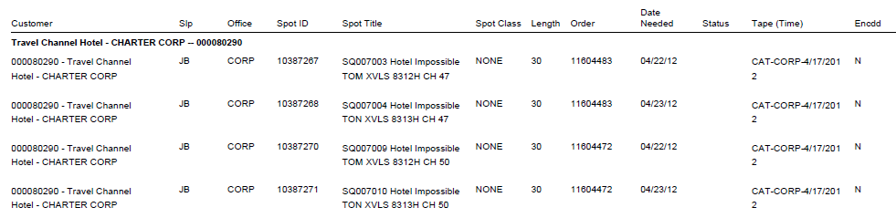

COPY REPORT BASICS

Copy Reports are generated through the Eclipse Web interface. This can be accessed directly at either <http://172.16.31.127/ewmapp/ewapp.cfm> for the Midwest/West region Eclipse database or <http://172.16.31.94/ewmapp/ewapp.cfm> for the Great Lakes region Eclipse database. Alternately, an Eclipse Web session can be launched from within the Eclipse Plus application as shown below.

1: Cllick on “Eclipse Web” on the upper right, and then click on “Reports” once it appears.

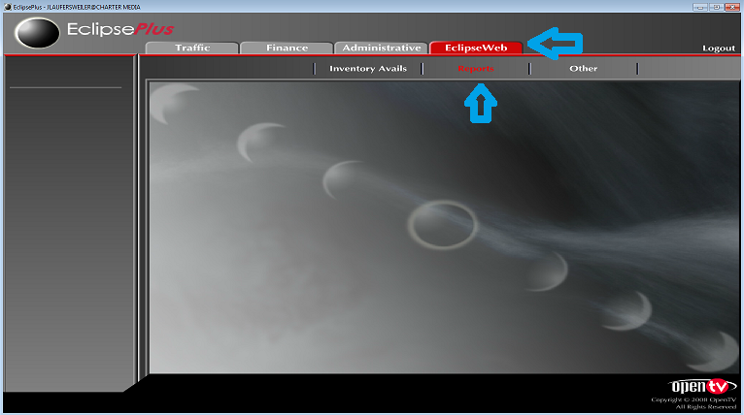

2: Click on “Traffic Reports” on the far left.

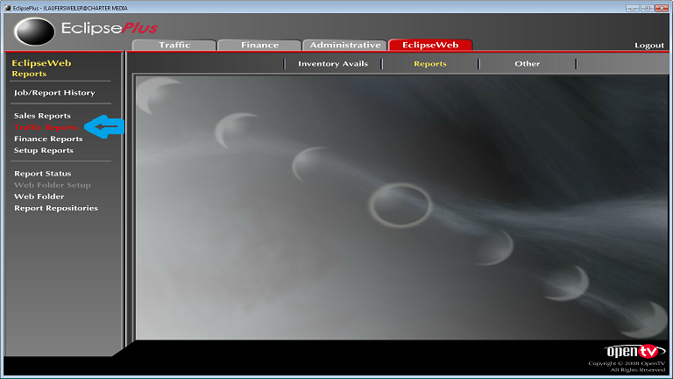

This will launch the Eclipse Web page in Internet Explorer for the same region you were logged into through Eclipse Plus.

If prompted, log in with the same ID and password you use for Eclipse Plus. This is normally the same credentials you use to log into Windows on your corporate computer.

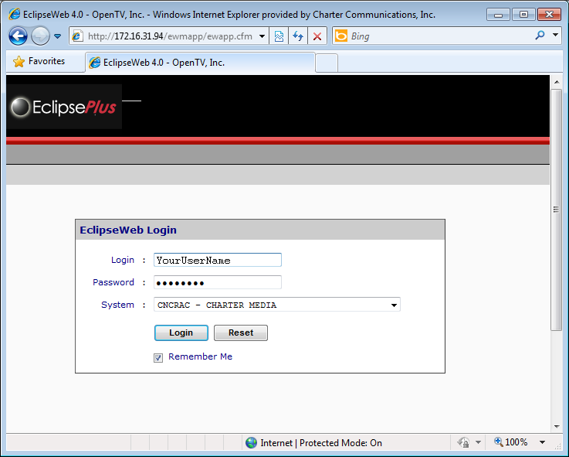

3: Click on “Run a Report” and then “Copy Report.”

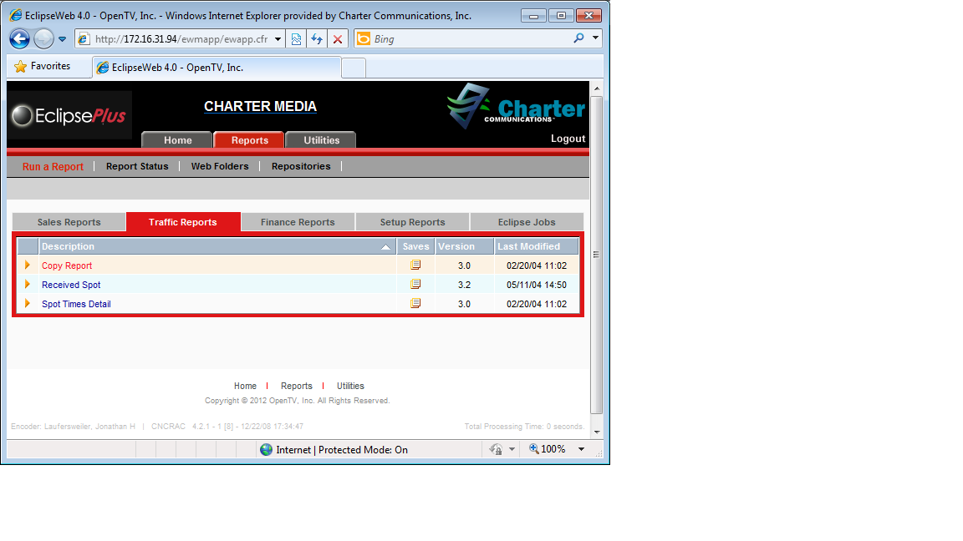

4: You will now be able to set the parameters for your copy report. Usually the only thing you need to change here is the range of dates for which to search for spots which need to be encoded. Once you have made your choices, click “Next” and then “Next” again on the following page.

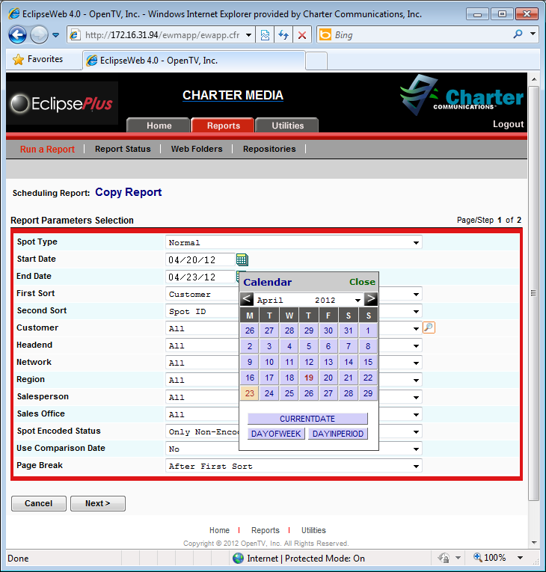

5: You can then choose you options for how your report is output. Check “Export as an Acrobat pdf document” for a basic printout. You may also check “Export raw data as” and fill in the radio-button for “CSV” (**C**omma **S**eperated **V**alues) if you wish to process the report data in an outside application, as will be discussed later in the chapter. Once you have chosen your output options, click “Submit.”

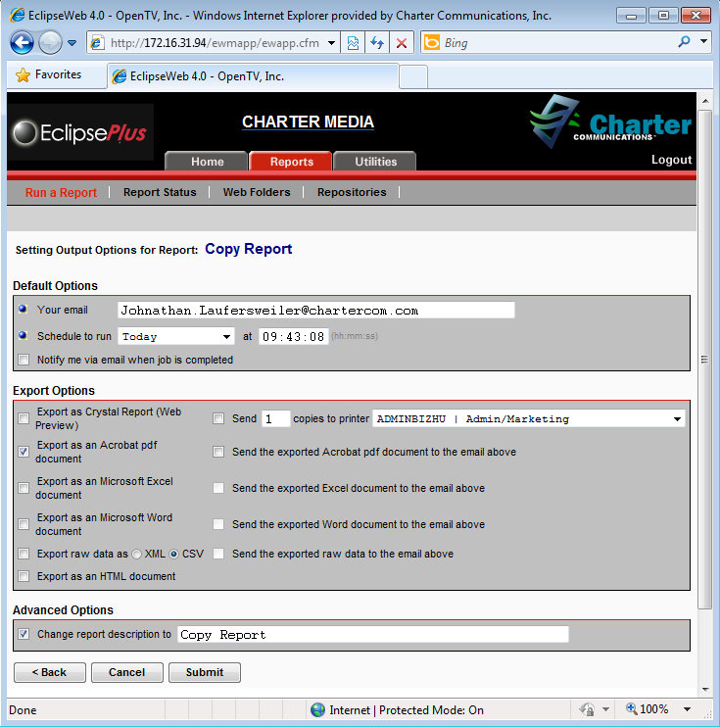

Once your report job has been submitted to the Eclipse database, the Eclipse Web page will re-direct you automatically to the “Report Status” page where you may monitor its progress and acquire your file upon completion.

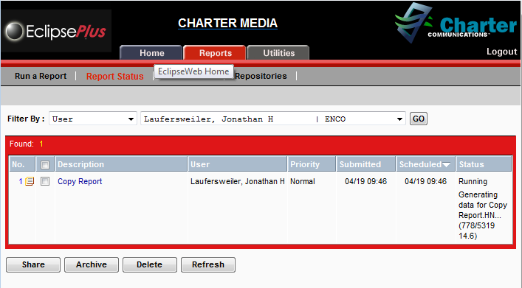6: Once the report is finished, click on the link for your file. Depending on the settings in your web browser, this will either open the report within the browser, open it in Acrobat Reader, or offer you a choice to save or open it.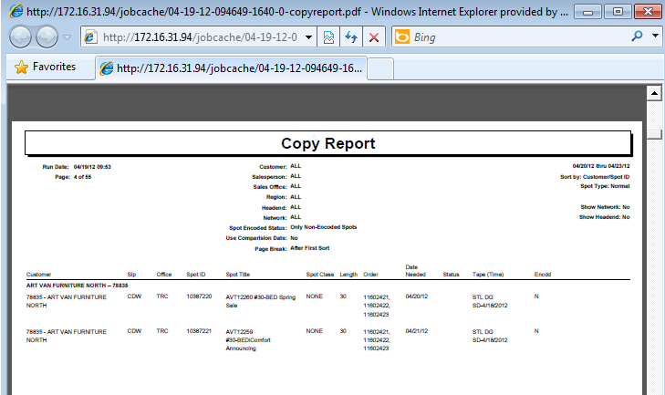

In any case, once you have the report open, press Control-P or otherwise print the report. The standard layout looks like this:

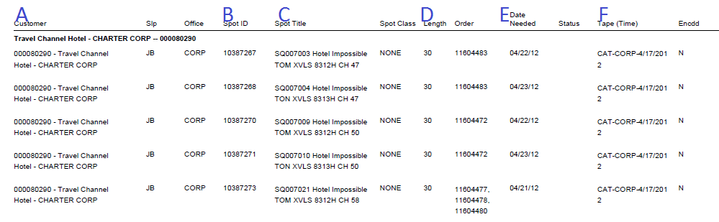Note the key fields: A: Customer , Spot ID, B:, C: Title, D: Length, E: Date Needed, F: Tape

ADVANCED OPERATIONS

Beyond a simple printout, Copy Report data can be manipulated programmatically by other applications for things like sorting spots by their run date, filtering for specific clients or “tape” locations, or using scripts to process files in batches. The full range of possibilities is beyond the scope of this document but we will examine a common example below.

If you output your report in a “raw data” format such as a CSV, you can then access all the data Eclipse has associated with that spot ID in a program like Excel. Here is an example of that data:

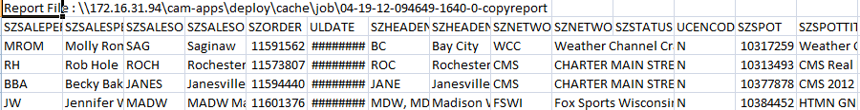We have an Excel macro available that sorts through this data, orders it by date needed and file location, and formats it for printing.

1: Open the CSV file from Eclipse Web in Excel (this should be the default option), click on the “View” tab and select “View Macros” from the “Macros” drop-down.

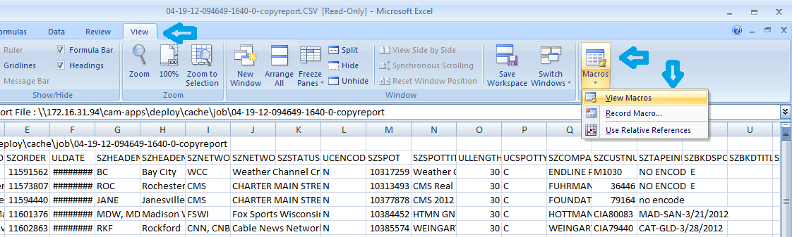2: From the Macros window, select the “Report” macro and click the “Run” button.

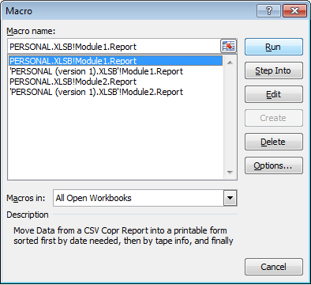

A new Excel workbook called “Copy Report Template” will open containing the data from the CSV file, sorted according to Date Deeded and Tape Info. There are separate tabs with headers for Printing reports for each region (though they will contain the same data).

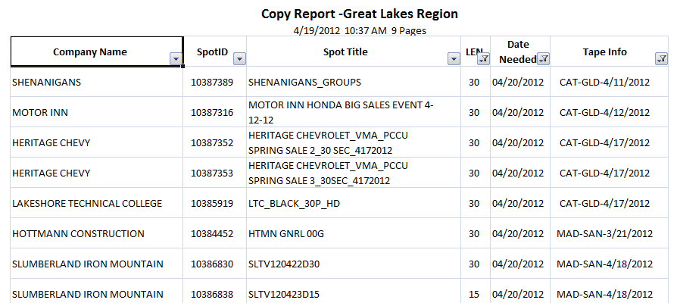

3: You may even use Excel’s filter drop-downs (already active in the template to refine your data-set, such as to exclude longform material or “no encode” Spot IDs from “verification only” networks like The Weather Channel.

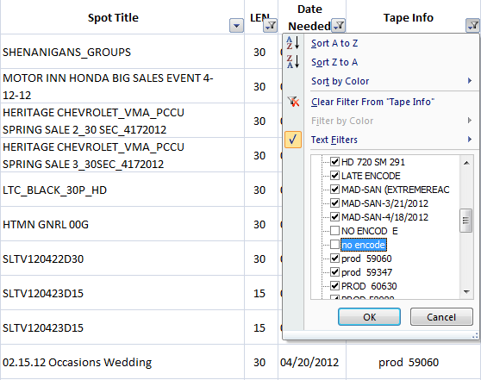

SUMMARY

By running copy reports regularly through the day, Encoders are able to stay on top of upcoming schedules. Printouts give us a handy way to organize the work at hand while accessing multiple computers. Analyzing the data allows us to prioritize impending spots, or work through them more efficiently.